Chapter 8 Sampled-Data Systems

Contents
§1 Introduction
§2 General Description
1. Pulse Sampling
2. Impulse Sampling
3. Shannon Theorem
4. Hold
5. Pulse Transfer Function
§3 z-Transform Method
1. Definition
2. Properties of z-Transform
3. z-Transfer Functions
4. General Procedure of Obtaining z-TFs
§4 Sampled-Data System Analysis
1. Stability Analysis in z-Plane
2. Bilinear Transformation
3. Time Response
§5 Compensator Design
1. Continuous Compensator Design
2. Digital Compensator Design
§6 Summary

§1 Introduction
1.1 Continuous Systems
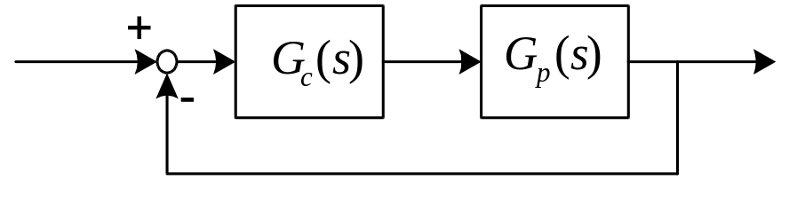
♦ 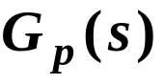 is the continuous plant
♦ 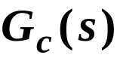 is the analog controller
♦ Time and magnitude are varying
continuously.
1.2 Sampled-data Systems
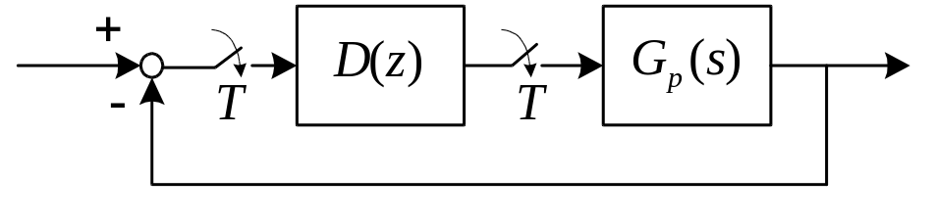
♦ is the continuous plant
♦ 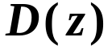 is the digital controller
♦ Continuous (analog) signals and
discrete (digital) signals exist
simultaneously
♦ Sampling switches, A/D and D/A
converters are employed
1.3 Discrete-time Signal and
Digital Signal
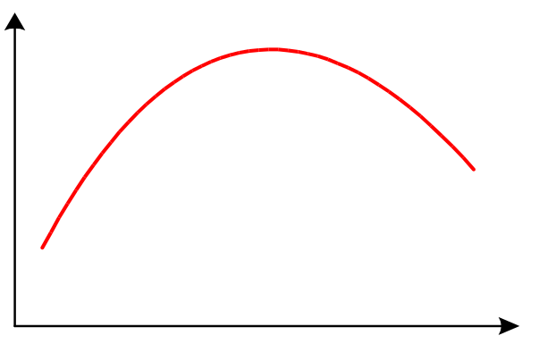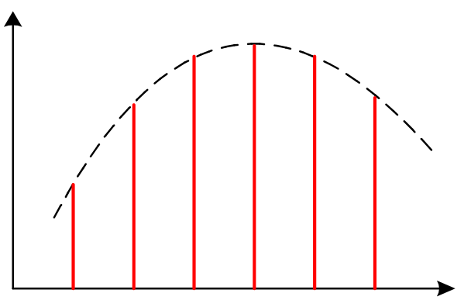
Continuous signal Discrete-time signal
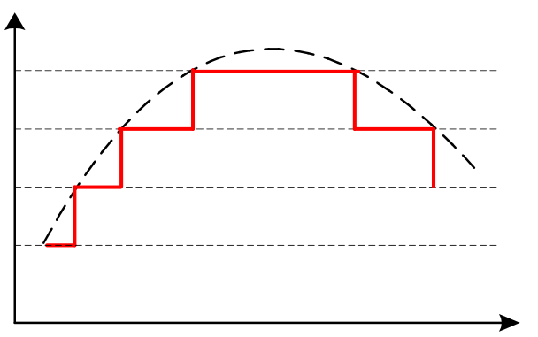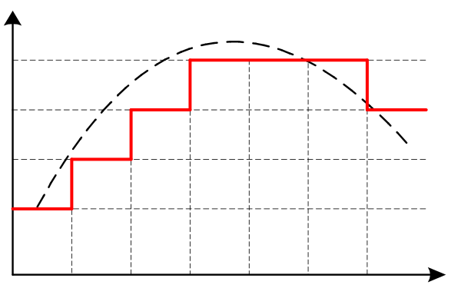
Quantized signal Discrete-time
quantized signal
1.4 Types of Sampling Operation
(1) Periodic sampling (conventional)
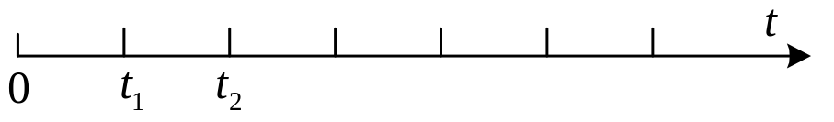
◊ 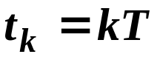, 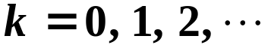
(2) Multi-rate sampling (parallel)
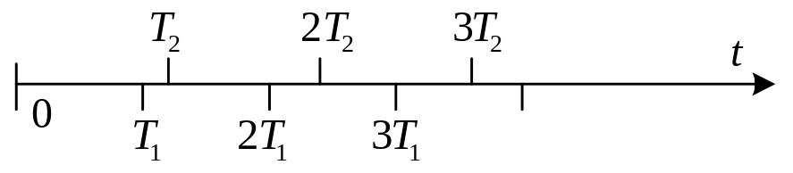
◊ 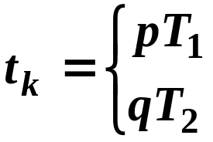, 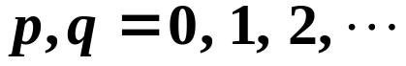
(3) Multi-order sampling
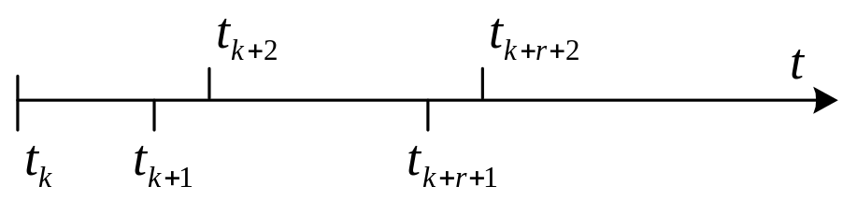
◊ 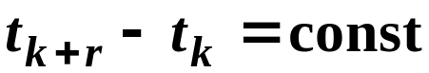, but 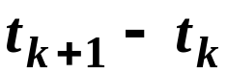 is
not necessarily equal to 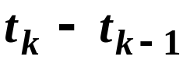
(4) Random sampling
§2 General Description
2.1 Pulse Sampling
1. Pulse Sampling
♦ Sampler: A switch with step output
as follows.
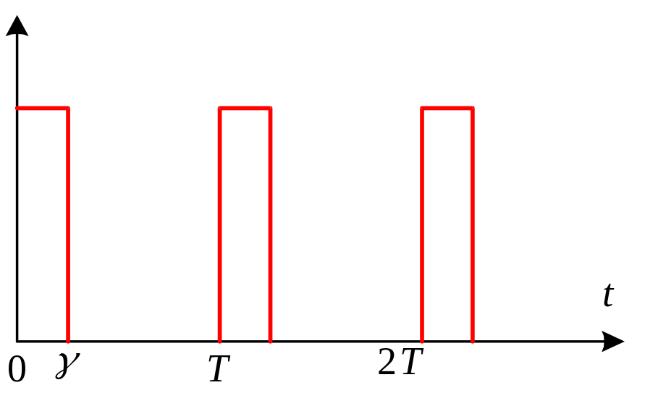
◊ Sampling interval 
◊ Sampling instants 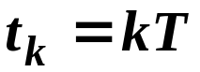
◊ 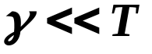
♦ Sampled signal:
Sampling operation is a magnitude
modulating process
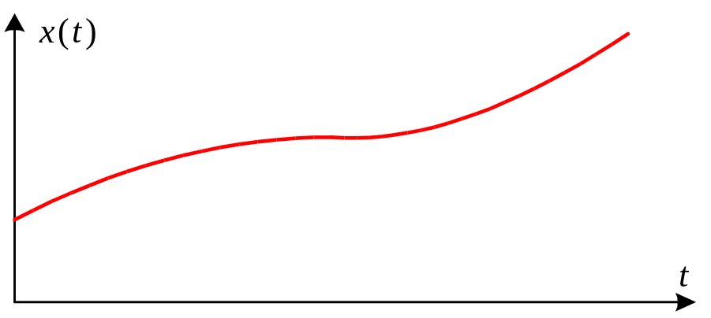
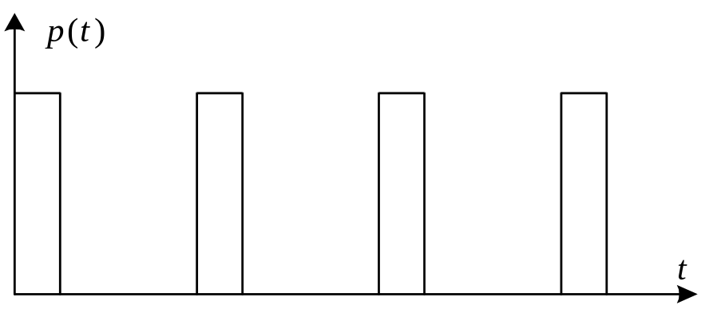
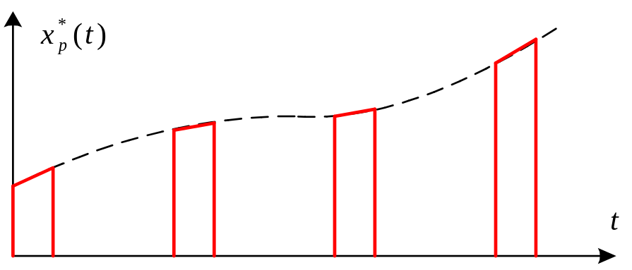
◊ 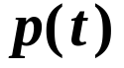 -- the pulse train
◊ 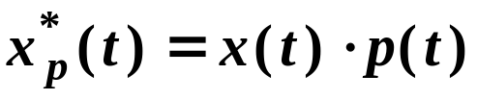
◊ The Fourier series of :
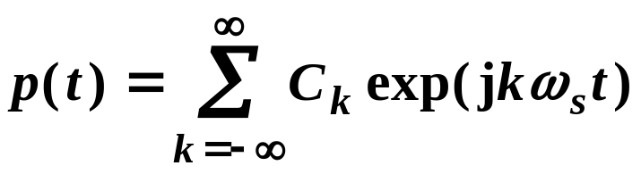
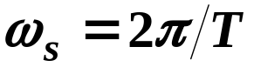
Calculations of 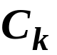 are complicated.
2. Impulse Sampling (Ideal Sampling)
♦ Ideal sampler
Let the height of the pulse be 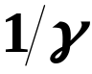
◊ 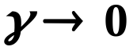 ⇒ ideal sampler
♦ Impulse train
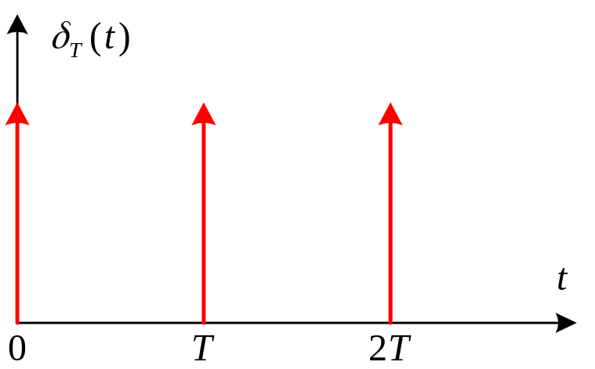
◊ 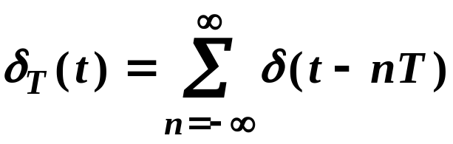
◊ Dirac 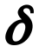-function 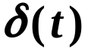
(i) 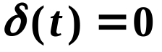 for all 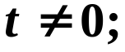
(ii) 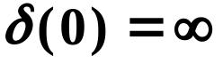;
(iii) 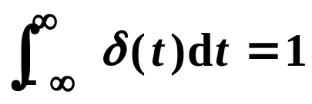
i.e. the strength of the impulse is unity;
(iv) 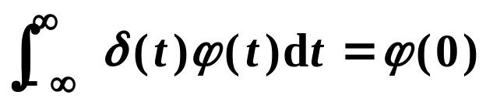
for all complex-valued function 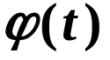.
♦ Sampled signal
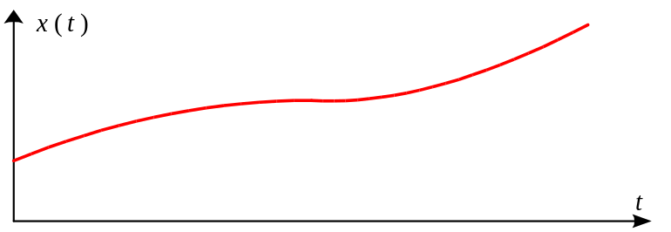
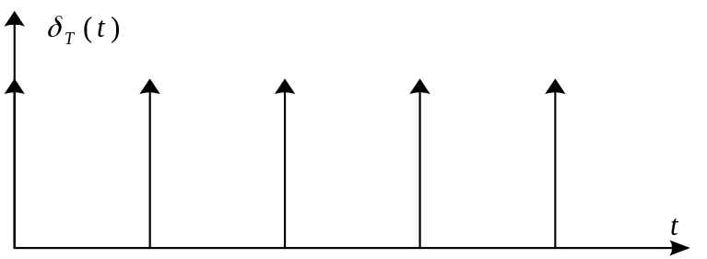
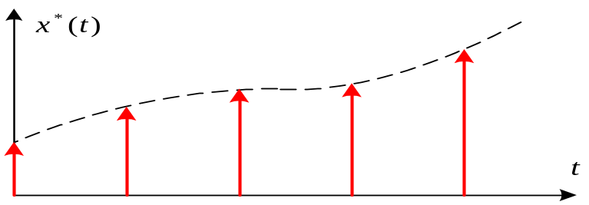

◊ 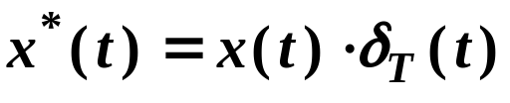
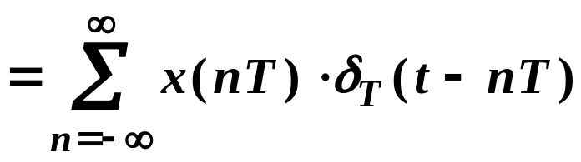
◊ Value of 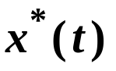 at (nT)
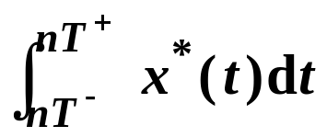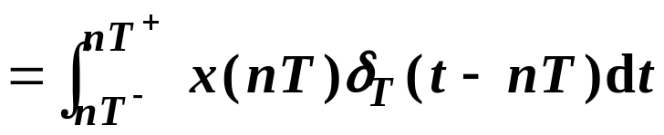
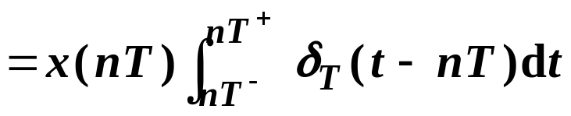
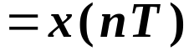
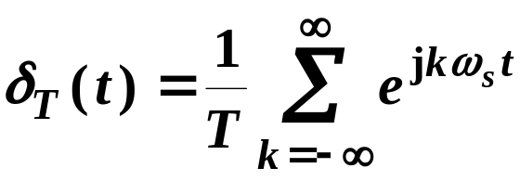
⇒ 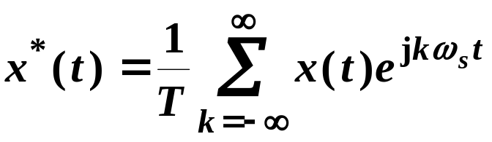
◊ Frequency spectrum of
Taking the Laplace transform
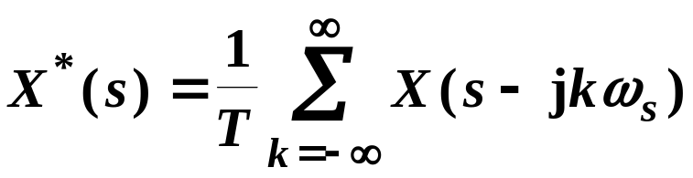
Let 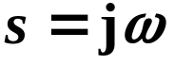, then
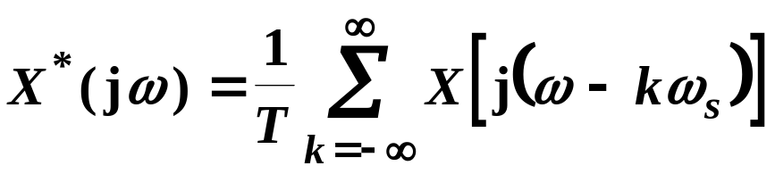
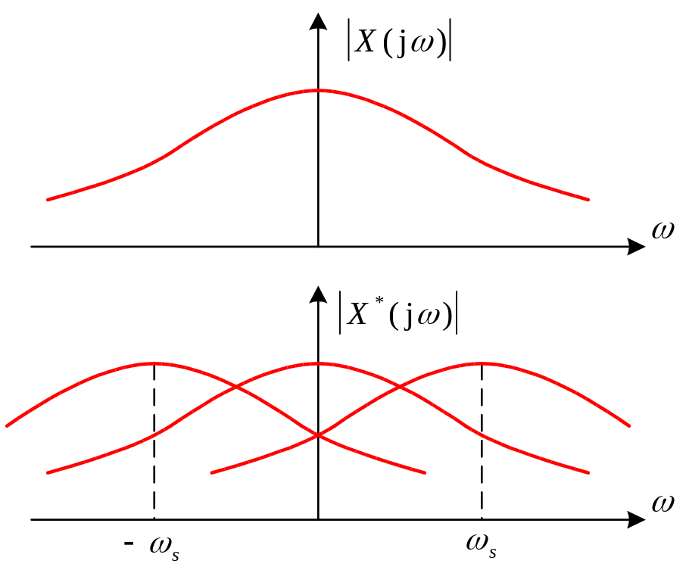

3. Shannon Theorem (Sampling Theorem)
Let 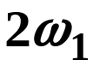 correspond to the spectrum of the continuous signal 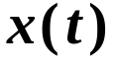.
♦ If 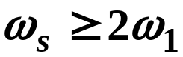,
then signal can be reconstructed
completely from the sampled signal
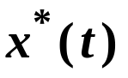.
4. Hold
♦ Zero-order hold:
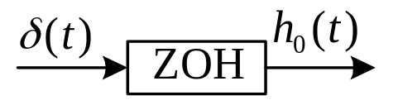 | 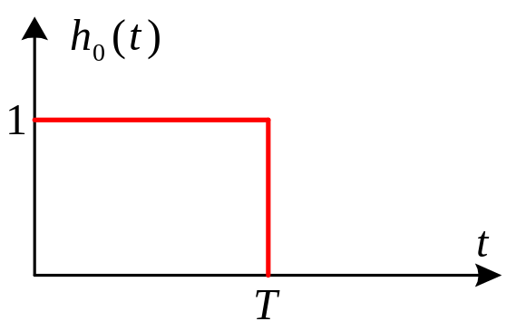
◊ 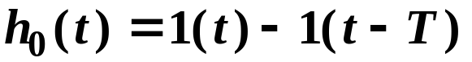
♦ Transfer function of ZOH:
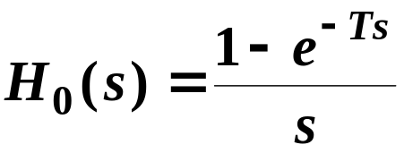
♦ Frequency response of ZOH:
Let and 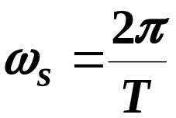, then
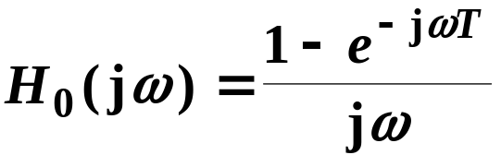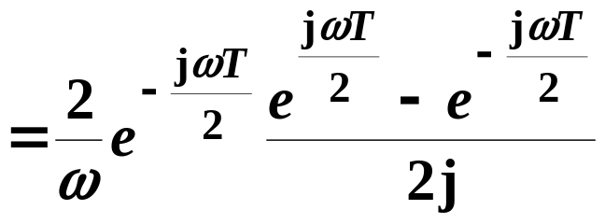
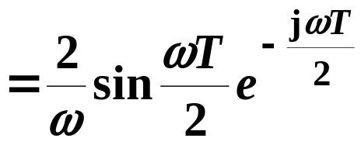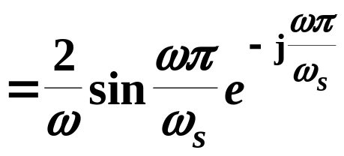
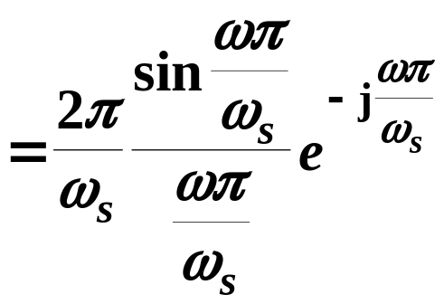
◊ Bode diagrams
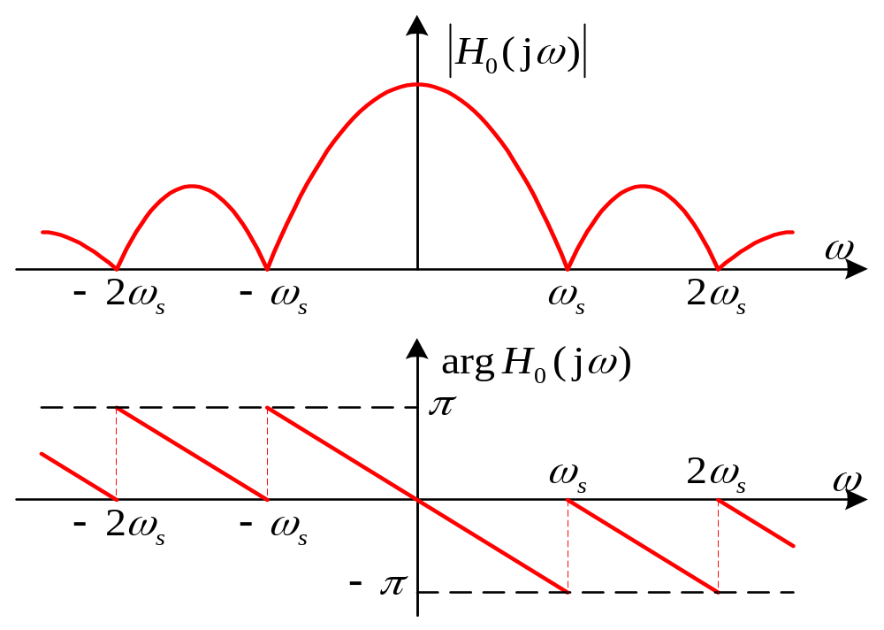
◊ Nyquist plot
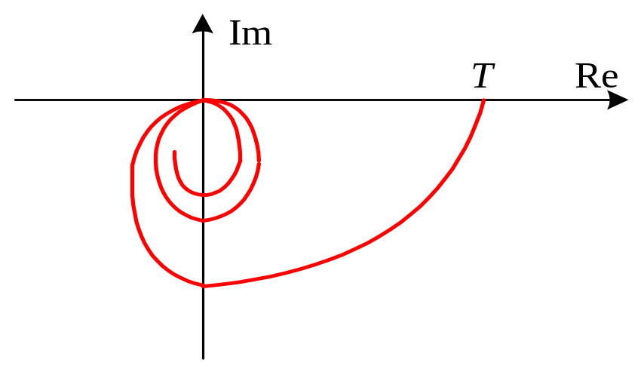
♦ Advantages of ZOH
(i) Only one recent data is needed;
(ii) When 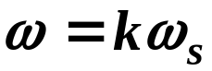, 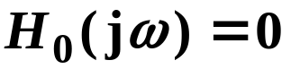;
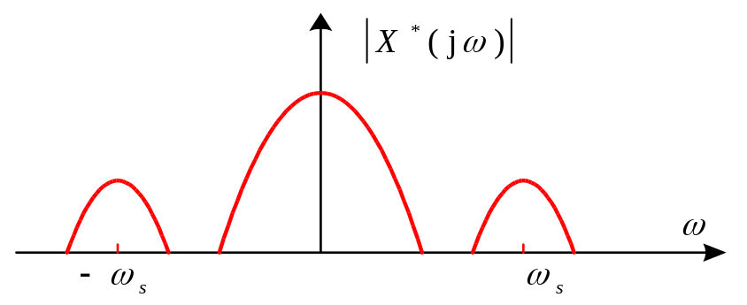
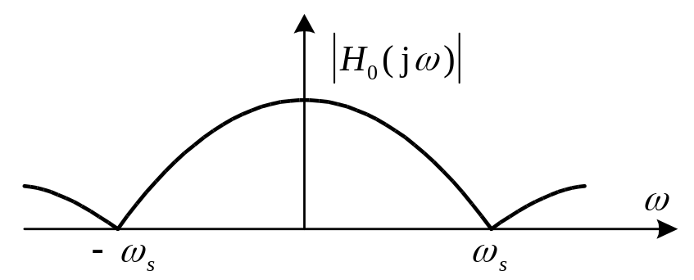
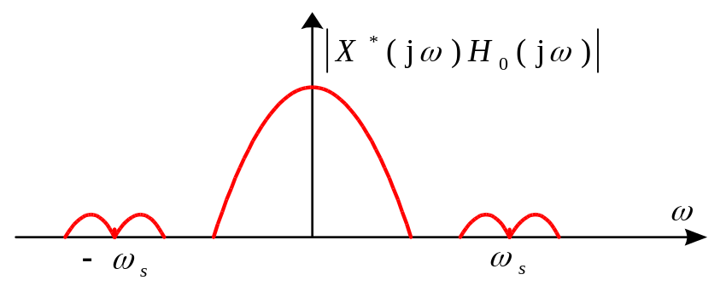
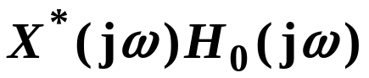 ～ 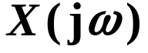
(iii) Phase lag less then 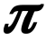.
5. Pulse Transfer Function
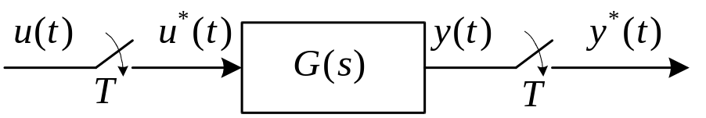
♦ Convolution summation:
At 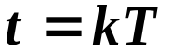
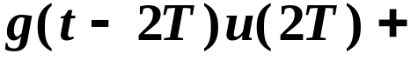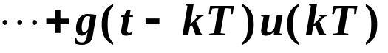
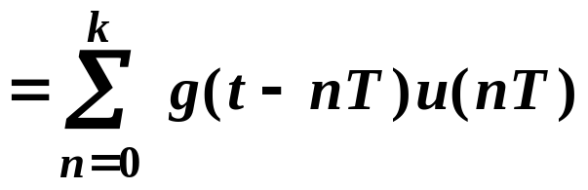
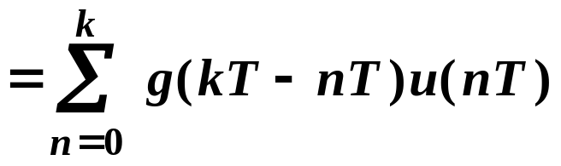
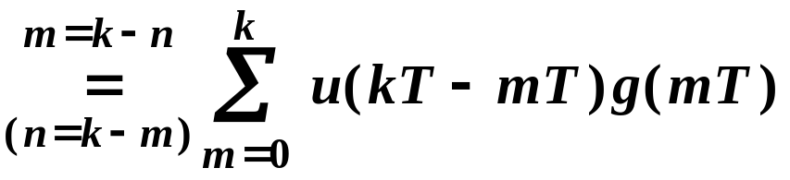
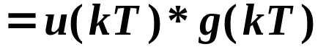
♦ Pulse transfer function:
◊ Definition:
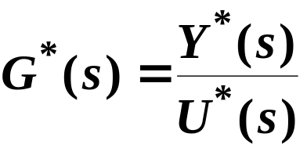
◊ Calculation
Taking Laplace transform of 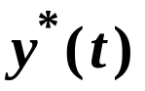 & 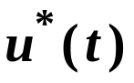
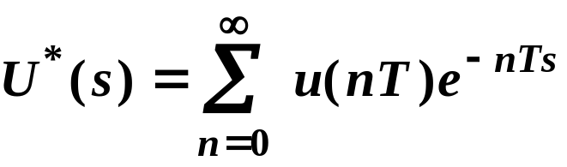
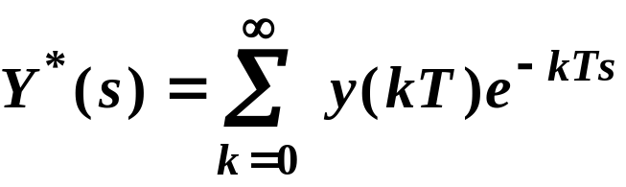
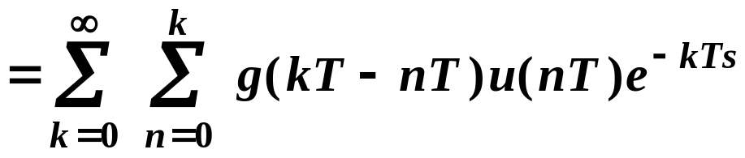
Since
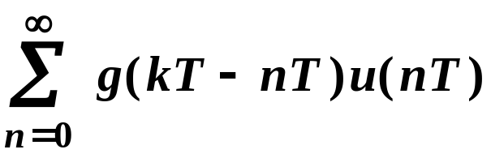
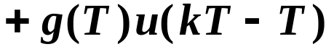
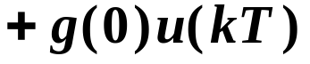
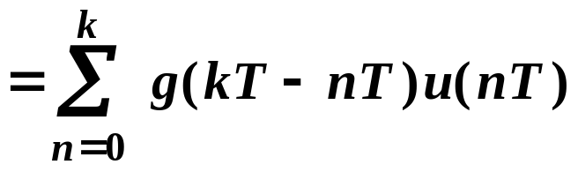
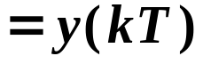
So,
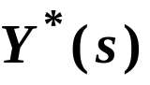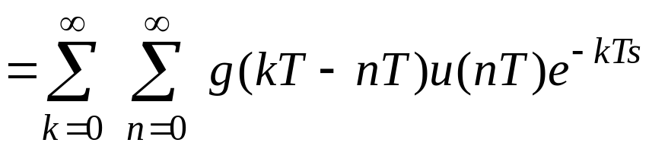
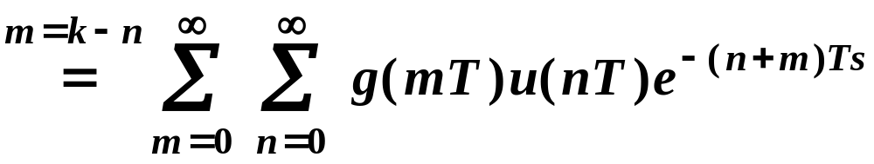
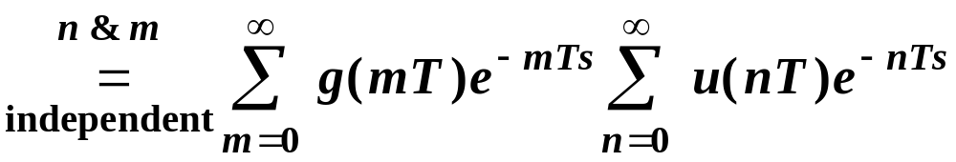
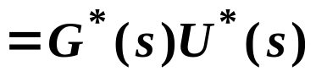
where 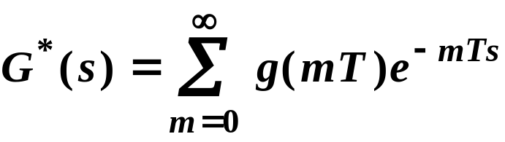 is the
pulse transfer function of the plant

♦ Obtaining pulse transfer functions of
sampled-data systems with discrete
input
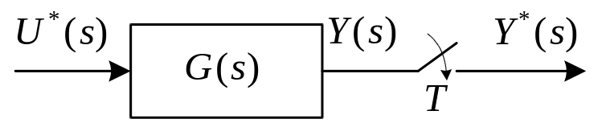
◊ 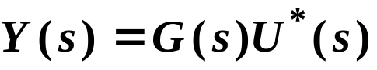
◊ By discretization
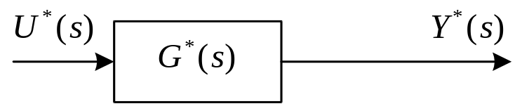
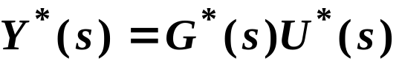
so
Example 2.1 Find the pulse transfer
function of the following system
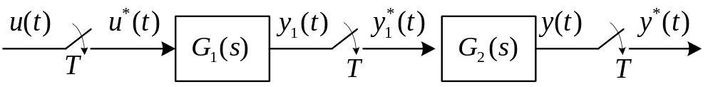
Solution:
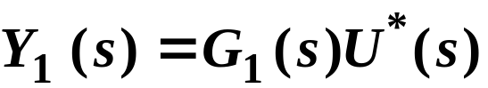 ⇒ 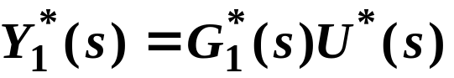
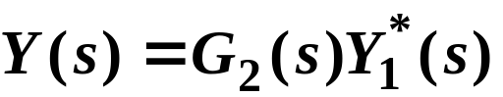 ⇒
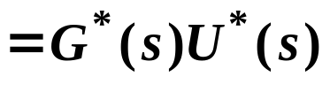
where 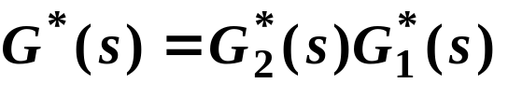
Example 2.2 Find the pulse transfer
function of the following system
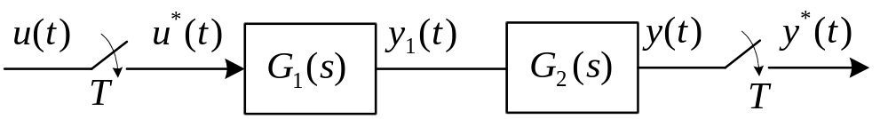
Solution:
Let 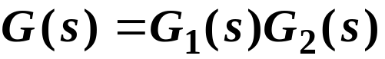, then
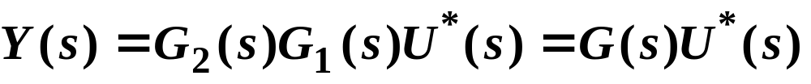
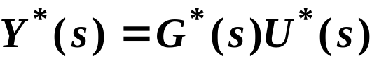
where
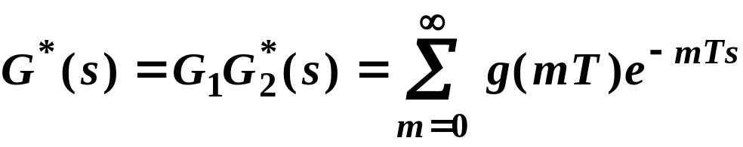
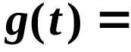L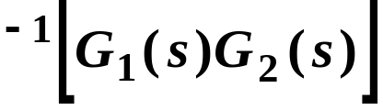
◊ N.B: In this case, 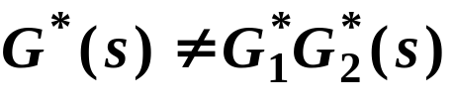
Example 2.3 Find the pulse transfer
function of the following system
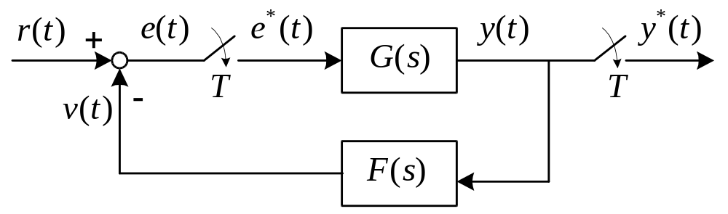
Solution:
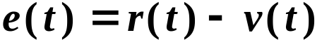, 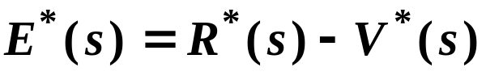
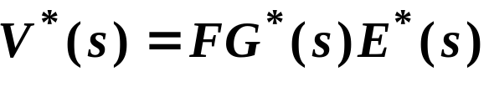
So 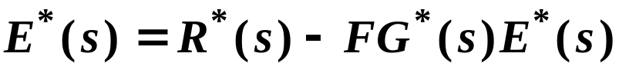
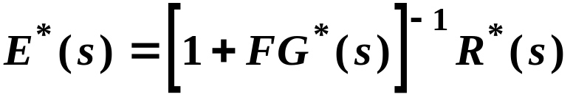
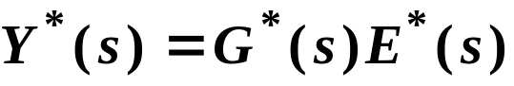
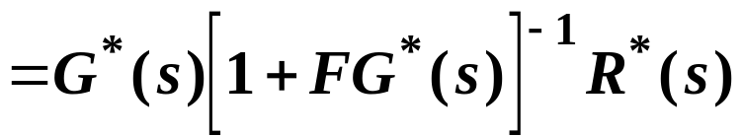
◊ CL pulse transfer function:
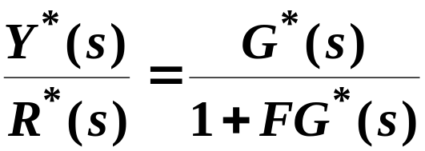
Example 2.4 Find the pulse transfer
function of the following system
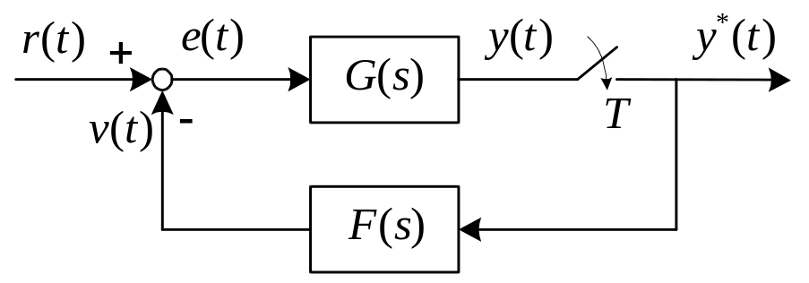
Solution:
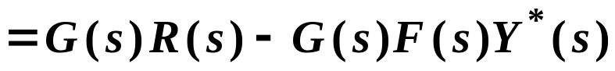
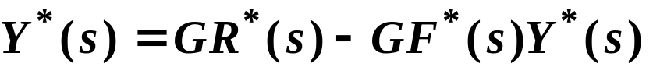
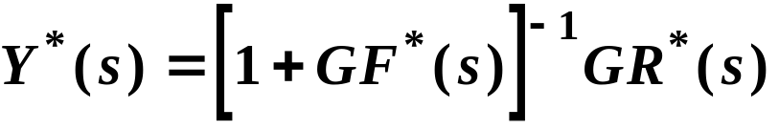
◊ No pulse transfer function
from 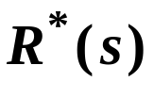 to 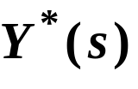

§3 z-Transform Method
◊ 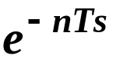 causes transcendental equations
◊ Inconvenient in analysis and design
3.1 Definition
♦ One-sided signal (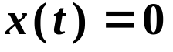 for 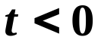)
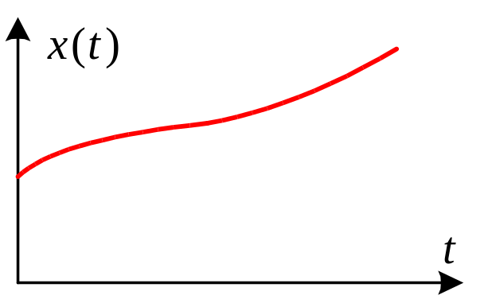
♦ Sampled signal:
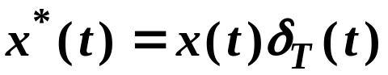
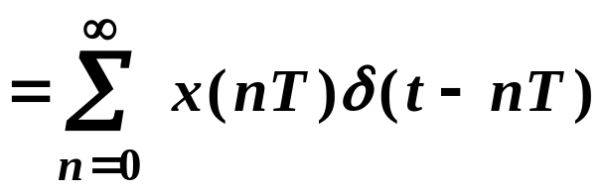
♦ Laplace transform of
L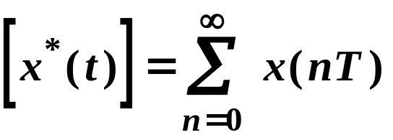L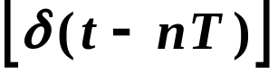
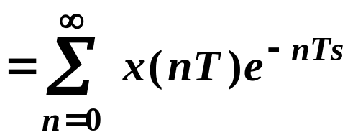
◊ 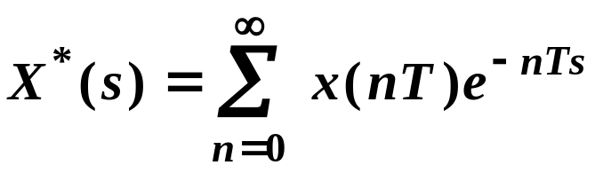
♦ z-transform of
Let 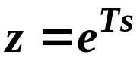
◊ 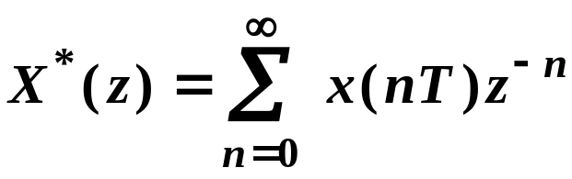
◊ Denoted by
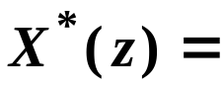Z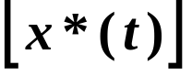
◊ Usually, we write
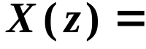Z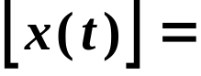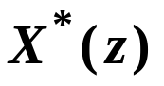
♦ Mapping between z and s
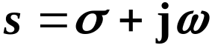 ⇒
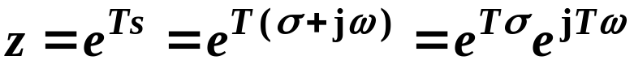
◊ Constant 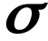
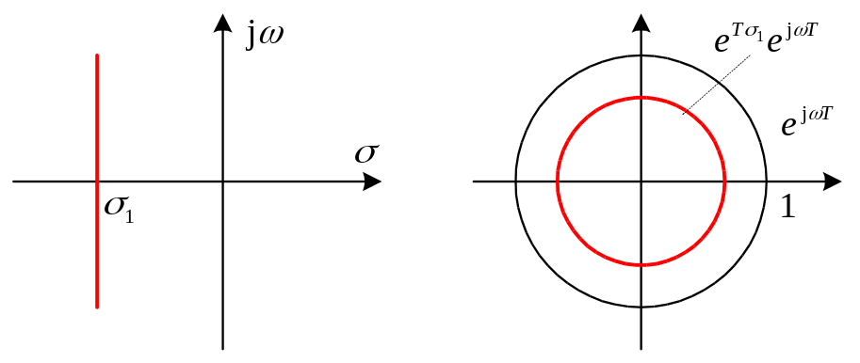
s-plane z-plane
◊ Constant 
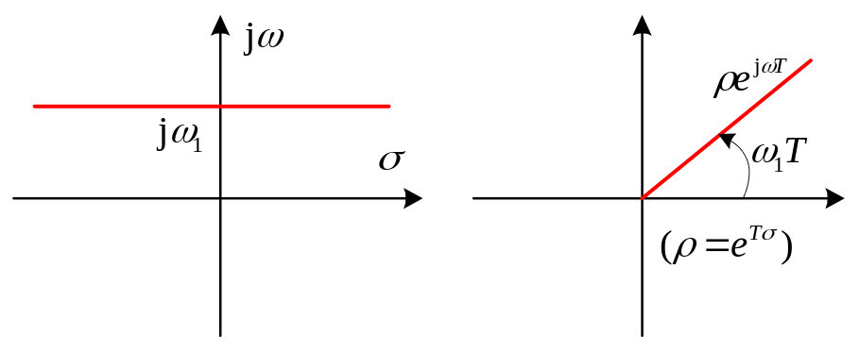
s-plane z-plane
◊ Constant 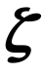
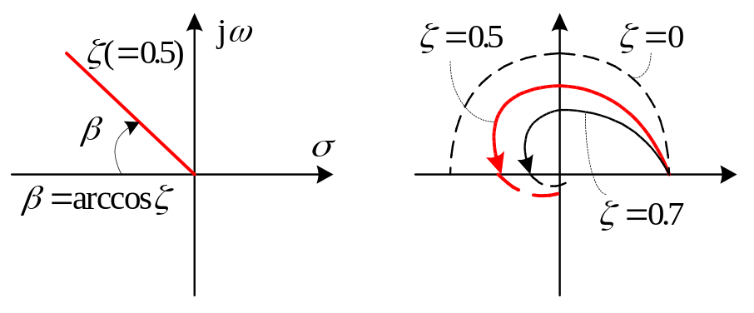
s-plane z-plane
3.2 Properties of z-Transformation
(Refer to any textbooks)
(1) Shifting theorem
Z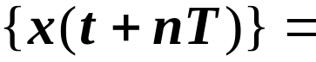  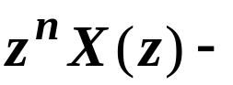  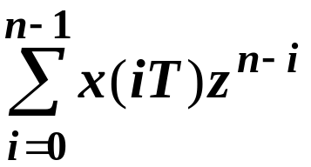 | 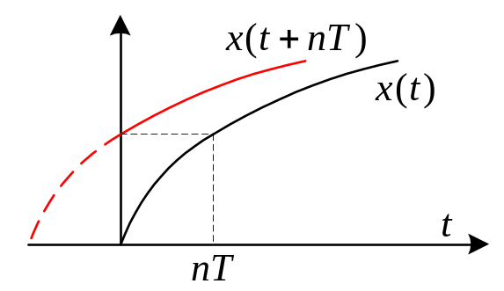
Z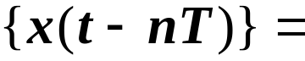  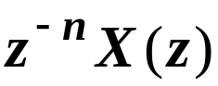 | 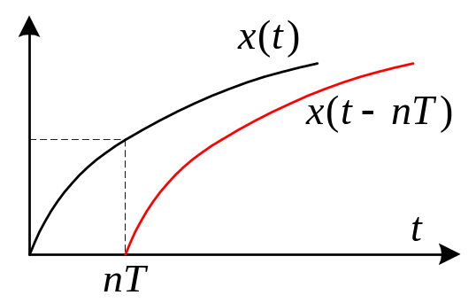
(2) Initial value theorem
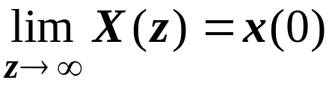 if 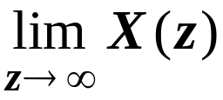 exists
(3) Final value theorem
If 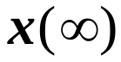 exists, i.e. 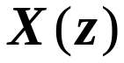 has no poles
on 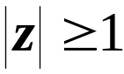 except 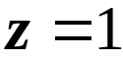, then
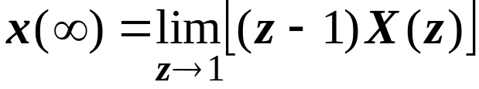
……and so on……
3.3 z-Transfer Functions
⇓ z-transformation
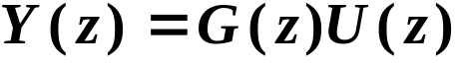
◊ 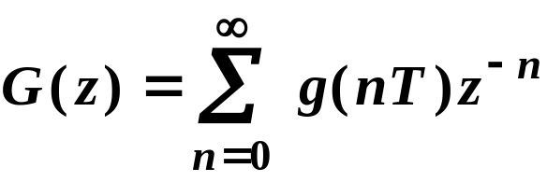
-- z-transfer function of plant 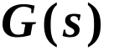
3.4 General Procedure of Obtaining
z-Transfer Functions
(1) Find between two samplers.
♦ If there exists a ZOH, then
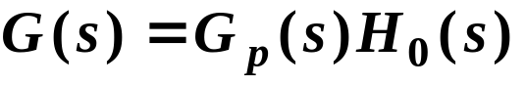
♦ should include all serially
connected transfer functions.
(2) Calculate
L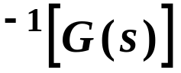
(3) Calculate
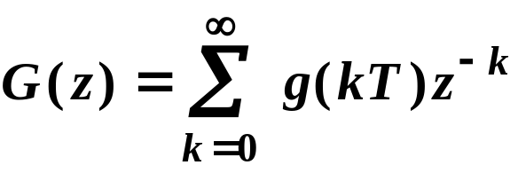
Example 3.1 Find the z-transfer function
of the following system
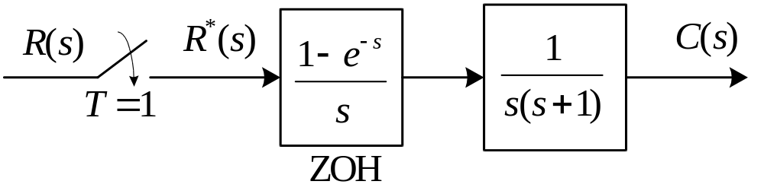
Solution:
(i) Method A:
Direct calculation
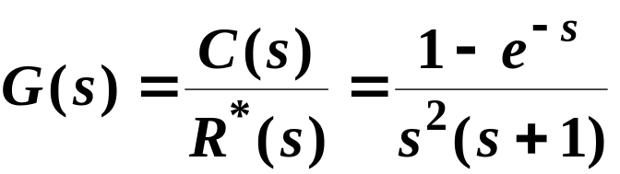
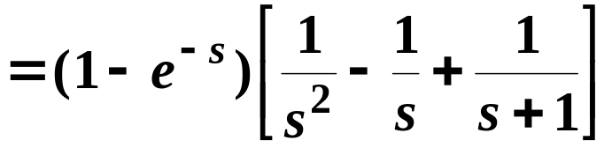
L
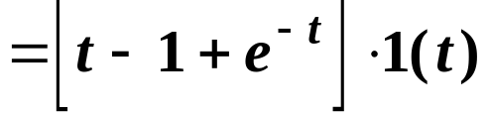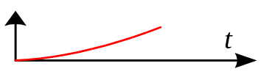
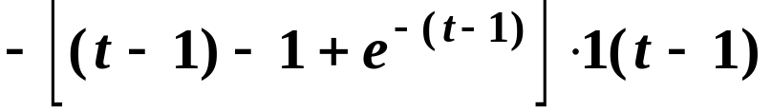
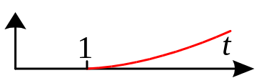
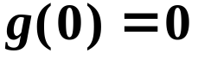
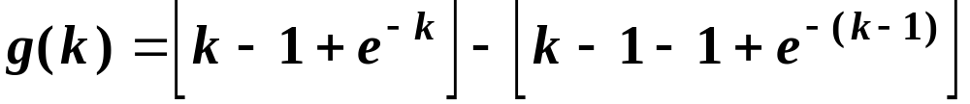
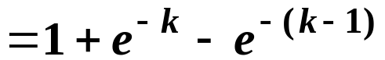 for 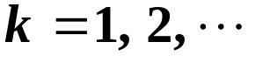
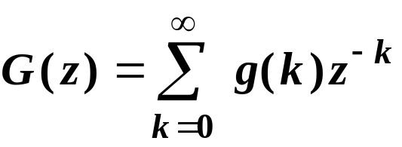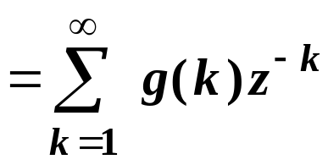
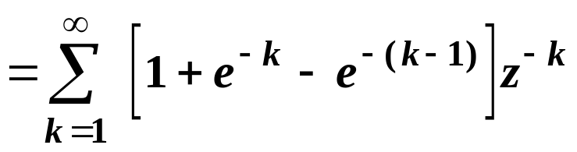
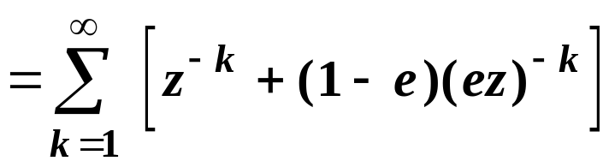
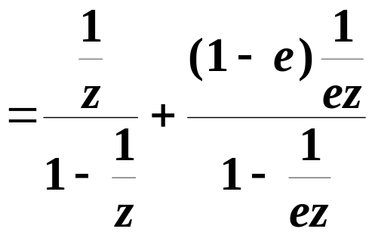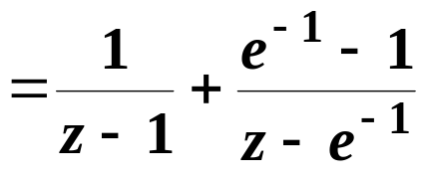
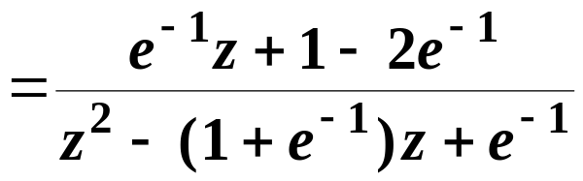
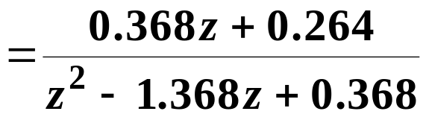
(ii) Method B:
By using the table of z-transforms
◊ Let
then
By using the addition and shift theorems
◊ Since 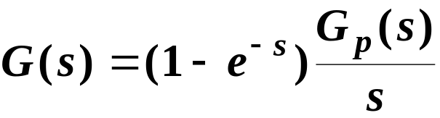
then 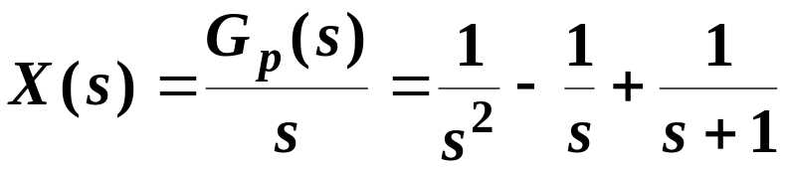
From the table of z-transforms
Z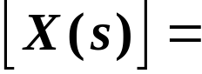Z